Name: Ronald Person
Theme: Funny Story
GitHub Pages Link: https://github.com/RonaldJPerson/Project-103/tree/main/Assignment%201

Screenshot

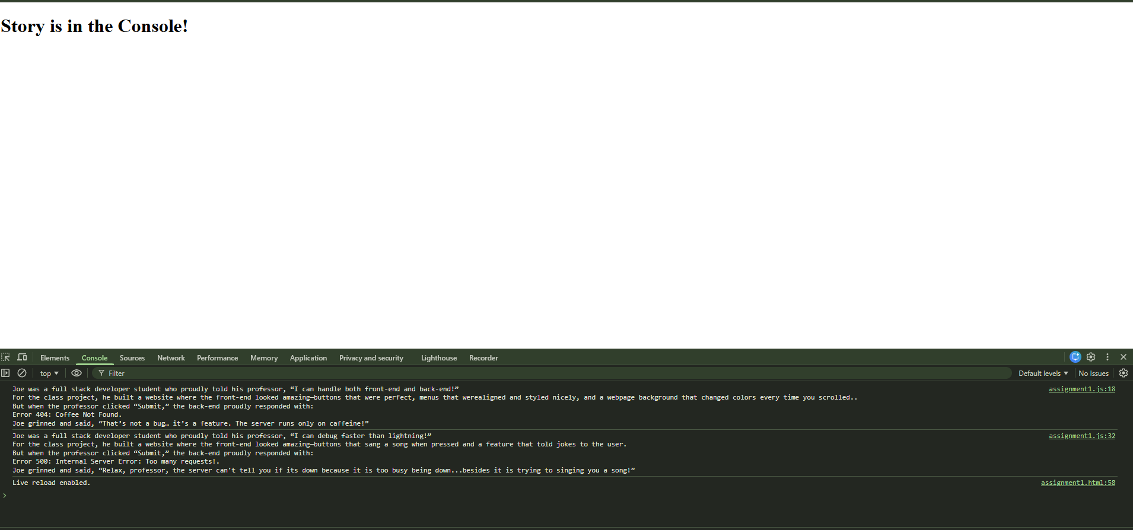
Summary of edits
- Created a new HTML file: assignment1.html
- Created a new JavaScript file: assignment1.js
- Created a funny story template with placeholders for various types of information
- Use let, and const to declare variables for each placeholder in the story (e.g., character names, actions, objects).
- Assign values to these variables to complete the story.
- Use console.log to output the completed story to the console.
- Change the values of the variables to create different versions of the story.
- Use console.log to output the completed story to the console.

